When we are going to work with FTP-Server we have to do the following:

1.Turn on windows FTP-Server feature under Internet Information Service

2.Create FTP-user

3.Authenticate the FTP-user to access FTP-Server data

4.FTP-Server configuration

1.Turn on windows FTP-Server feature under Internet Information Service:

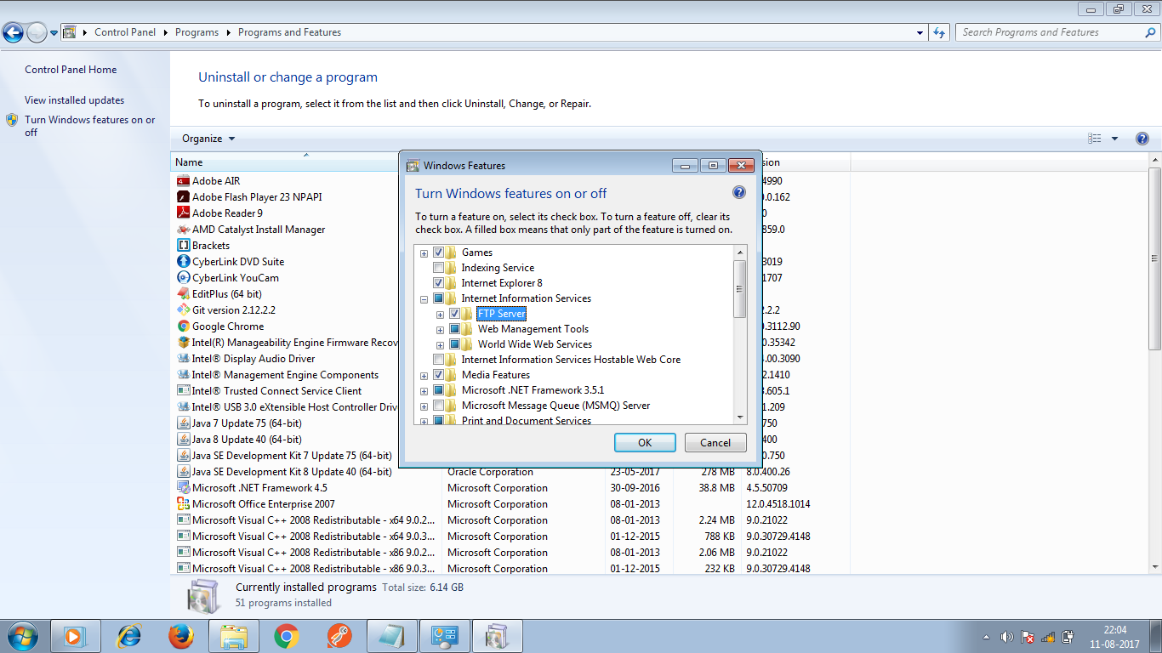

2.Create FTP-user:

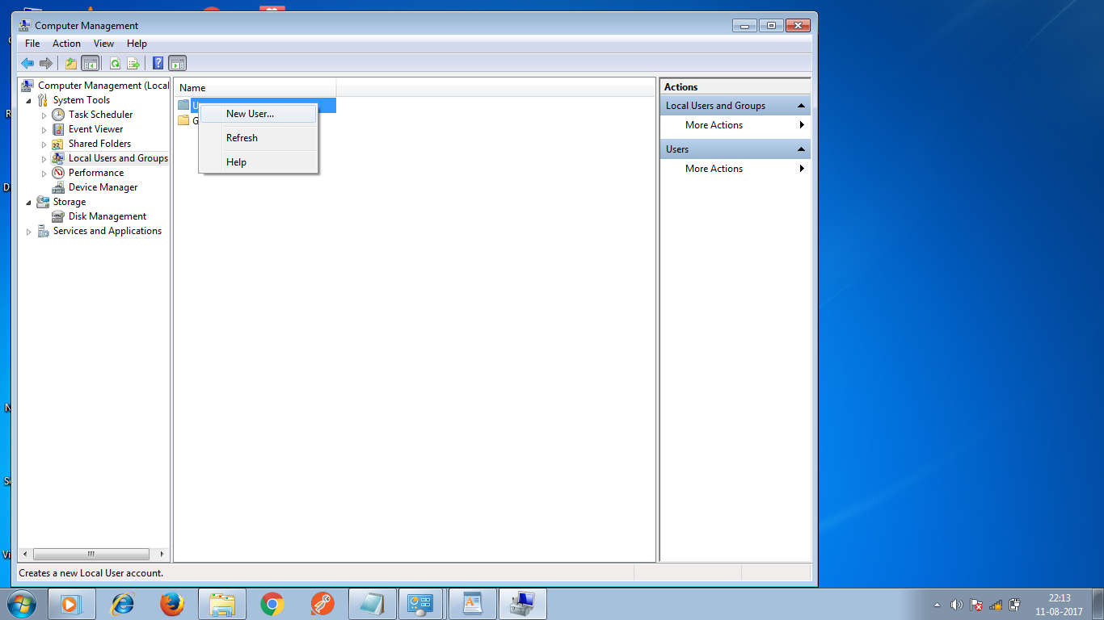

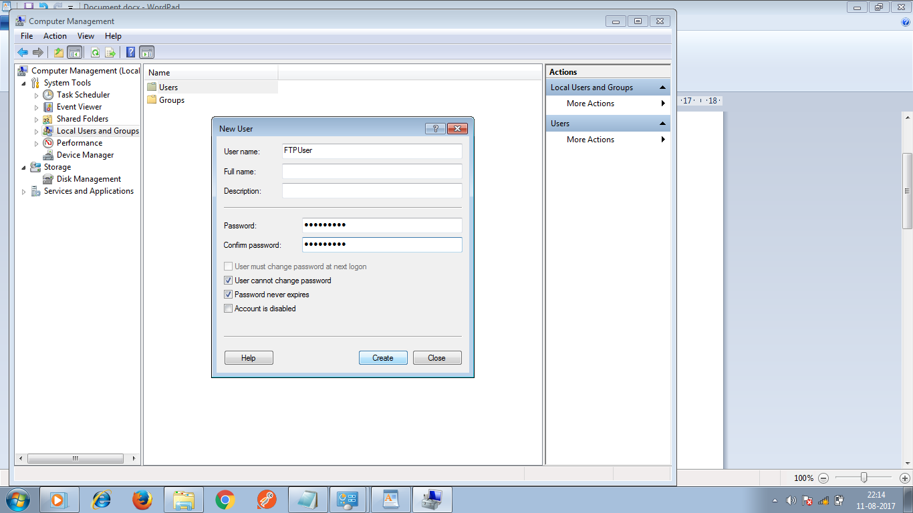

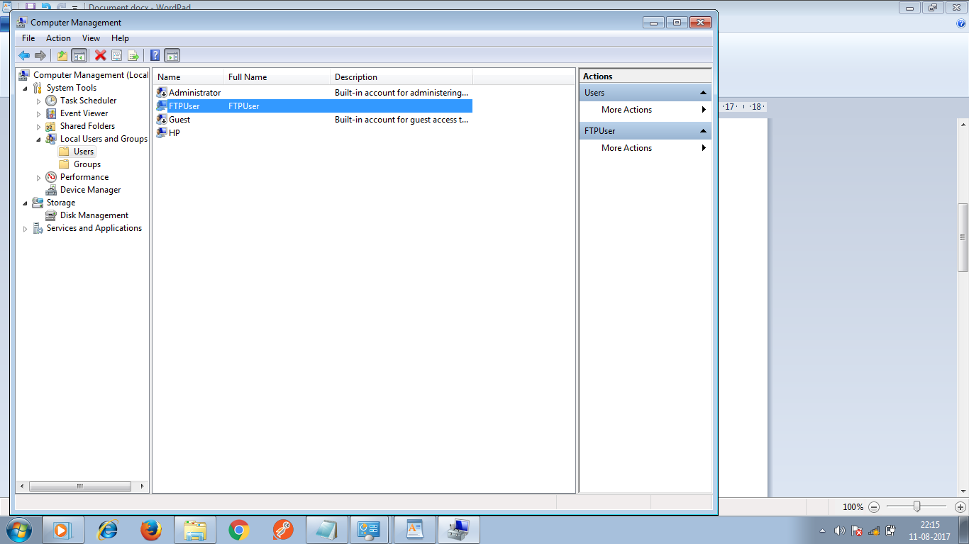

3.Authenticate the FTP-user to access FTP-Server data:

Go for properties of required folder that we want to access.

------->select security tab

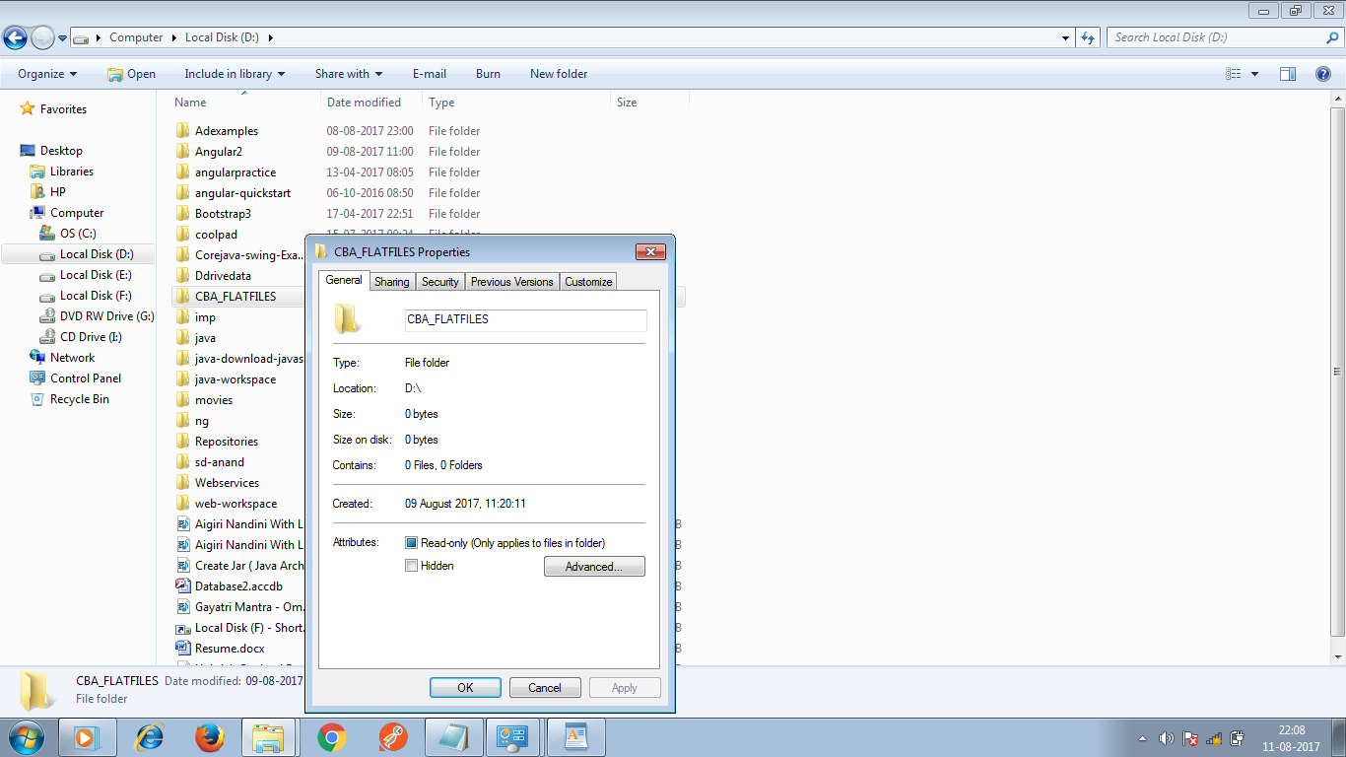

------->click on Add button

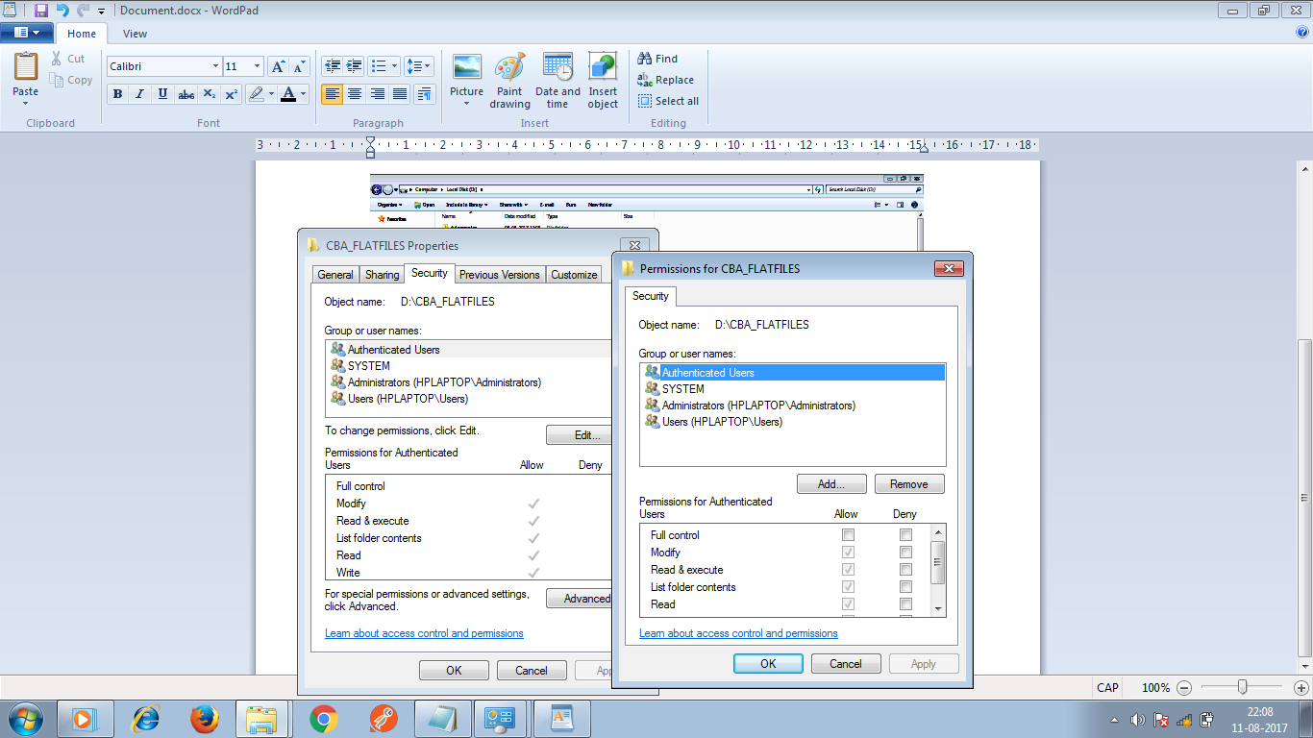

---------->Enter username--->click on check Names button---->ok--->Apply--->ok

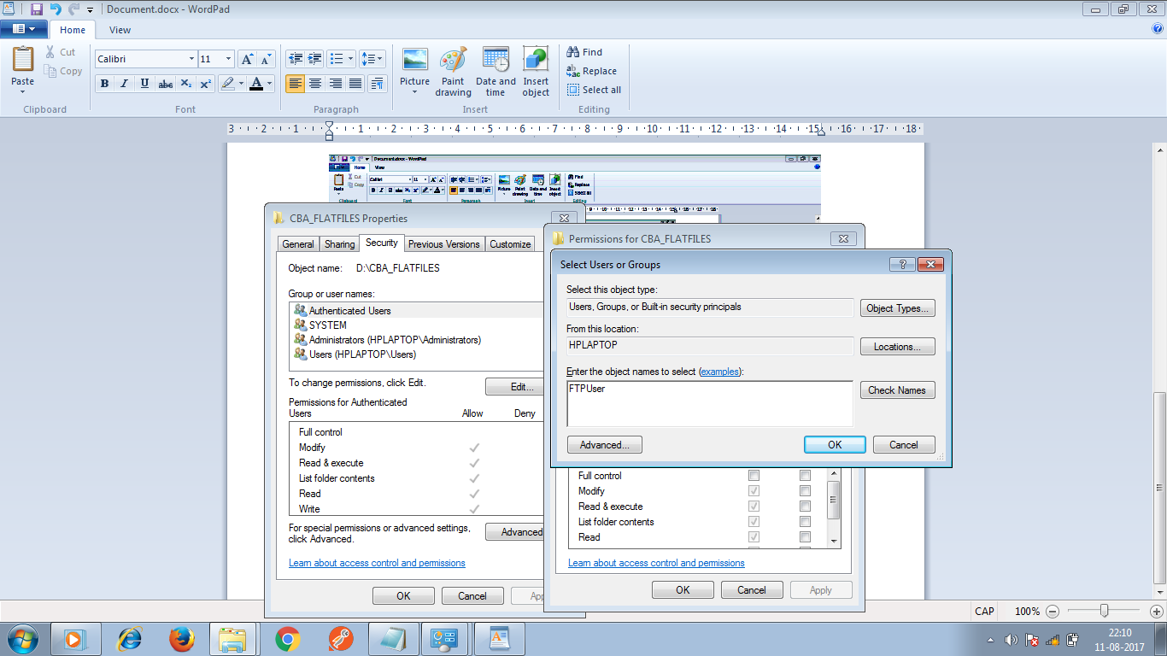

4.FTP-Server configuration:

Go for Administrative Tools -->open Internet Informatin service Manager.

